Forest School at Roman Way School

Forest School Handbook
Information for adults helping with Forest School activities in our school woodland
and families of learners at Roman Way School.

Version 1.0 Dated September 2025 Review Date : September 2026

Contents of handbook
1. Forest School ethos and introduction to Forest School…………………………………………………………………………3-4
2. How does the Forest School approach fit within our school vision and values…………………………………………5
3. Code of conduct………………………………………………………………………………………………………………………………………6
4. Links to school and learning………………………………………………………………………………………………………………….7-8
5. Equal opportunities………………………………………………………………………………………………………………………………….9
6. Health and safety…………………………………………………………………………………………………………………………………….9
7. Risk assessments……………………………………………………………………………………………………………………………………10
8. Emergency procedure and first aid………………………………………………………………………………………………………..11
9. Daily operating procedure……………………………………………………………………………………………………………………..12
10. Weather conditions……………………………………………………………………………………………………………………………..13
11. Activities…………………………………………………………………………………………………………………………………………14-16
12. Equipment and clothing………………………………………………………………………………………………………………….17-22
13. Ticks and Lyme disease…………………………………………………………………………………………………………………..22-23
14. Permission forms……………………………………………………………………………………………………………………………24-25
Forest School ethos and its benefits
Forest School came from a passion for nature that the Scandinavians call ‘Friluftsliv’ (pronounced free-loofts-liv). The expression literally translates as ‘open-air living’ and is seen as a way of life in Scandinavia where Forest School began. It arrived in the UK in 1993 and has grown from strength to strength since then. Activities are child initiated, allowing the children to explore the outdoors and make choices about their own learning. The practitioner’s role is to observe and support the natural curiosity children have for the world around them, enabling the children to make decisions.
Forest School is a long-term process of regular sessions that take place within a natural environment. This supports and develops a relationship between the learner and the natural world. Forest School aims to promote the holistic development of a young person allowing them space and time to learn about themselves and see their worth within the world. It fosters resilience, confidence, independence and creativity. Forest School offers young people an opportunity to understand risks, take risks that are appropriate for the environment and young person, as well as developing problem-solving skills. By connecting to the world around them the learners will become more aware of our ever-changing world, understand the role they play to care and nurture the life around them.
Roman Way Forest School Leaders are Mrs Reid and Miss Morgan – As practitioners we are committed to supporting the importance of play, both indoors and outdoors, and the value of risk taking. We support children’s play throughout the session taking into account the age, interests and individual needs of the child. We provide provision in which children can play in a safe and secure environment. Children are encouraged to make choices and think critically through independent play in on a one to one, small group or larger group. Play is children’s work. Through play children can explore, investigate, discover, create, practice, rehearse, repeat, revise and consolidate knowledge already gained to help develop new skills for now and in the future. It is essential for keeping children healthy and reaching important social, emotional, and cognitive developmental milestones. It also helps children to manage anxiety and become resilient. Outdoor play is an integral part of the curriculum. It offers opportunities for children to develop their gross and fine motor skills, experience the natural environment in all seasons. Guidance on supporting high quality play within the environment includes:
• Having adequate time to explore and play in the outdoor area.
• Finding out about the living natural world and how to look after it appropriately.
• Using natural and man-made materials to build, shape, assemble on both large and small scale.
• Having space to move in a variety of different ways
• Providing adequate space for children to use and explore
• Taking manageable risks

The benefits are many and will include the opportunity for children to:
• develop their personal and social skills
• develop their language and communication skills
• develop practical skills and improve physical motor skills
• work through practical problems and challenges
• use tools to create, build or manage
• pursue knowledge that interests them
• build confidence in decision making
• evaluate risk
• explore connections between humans, wildlife and the earth
• reflect on learning and experiences
• regularly experience achievement and success which will lead to motivation
• learn how to manage failures
• discover how they learn best
• improve their concentration skills
• understand the benefits of a balanced and healthy lifestyle

How does the Forest School approach fit within our school vision and values?
'…to work in partnership with families to unlock the potential of every individual. Together, we nurture a self-belief and a lifelong passion for learning.' Forest Schools will offer the opportunity for children to excel in different ways to traditional academics.
Our school SHIELD values underpin everything we do.
Safety
Honesty
Integrity
Excellence
Love
Determination

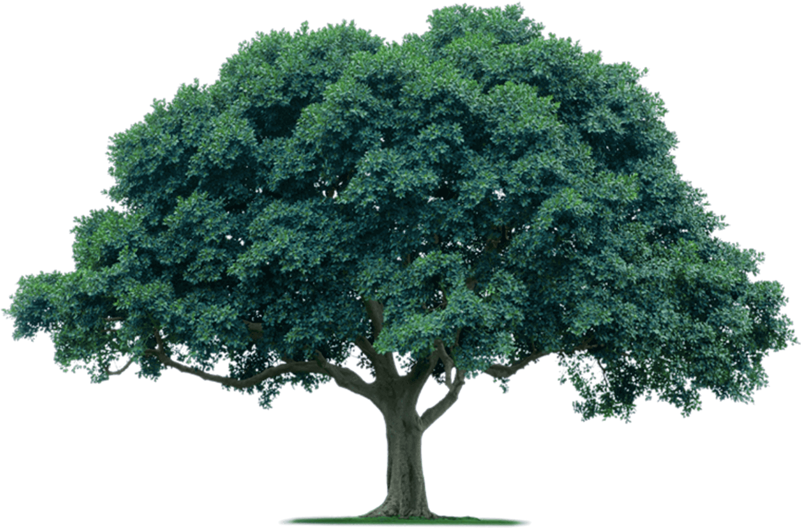
Forest School code of conduct
Throughout each session, children become involved with the setting and understanding of the Forest School rules to ensure their safety. At the beginning of every session a quick revisiting of the rules is reinforced by the children following our Code of Conduct.

Policy during Forest School sessions I will agree to:
https://primarysite-prod-sorted.s3.amazonaws.com/roman-way-primary-school/UploadedDocument/f09bc3f4-f753-452c-bc92-9ae7e0b69fde/rw-behavioural-policy-2024.pdf
• Always follow the school values
• Listen carefully to my Forest School Leaders
• Care for nature, myself and those in my group
• Move safely within the Forest School agreed boundary
• Assess my surroundings before I move, drag or throw items
• Ask an adult before I take/use any tool and follow the tool rules. Return tools immediately after use.
• Keep everything out of my mouth –‘No lick, no pick’.
• Always wash my hands after a session

Links to the school and learning
Links to other aspects of learning
https://primarysite-prod-sorted.s3.amazonaws.com/roman-way-primary-school/UploadedDocument/e0dcf7e9-db2a-4906-b49e-c55355422b11/teaching-and-learning-policy-2023.pdf
Forest School Links to all aspects of curriculum:
Maths – Learners will be given opportunities and measure the circumference of a tree to work out the age of the tree. Learners will explore shapes and colours within nature and make links between themselves and the world around them. Pinecones and acorns will be collected and divided as we learn about hibernation or make art projects. We have opportunities to count and identify items around us by colour and shape.
Science – Learners will experience first hand the changing natural environment throughout the seasons, looking at the changes with the insects and wildlife, the weather, as well and the plants and fauna that grow. Forest School is living breathing science. We will have opportunities to identify bugs, plants and wildlife. When building fires and cooking we will understand the science behind fires and the long-term impact of fires on the surrounding area.
Environmental education and ecology https://www.romanwayprimary.org/eco-schools-award/ woodland trust green school award – recently achieved gold standard – as the school works towards becoming and Eco School the young learners will have opportunities to contribute towards this award, with activities that will be offered via Forest Schools, such as bird feeders, taking part in surveys, developing a vegetable/garden area, litter picking and recycling. The learners will deepen and engage with the changing world around them and develop an understanding of sustainability, encouraging them to take a wider interest and the changes they can make.
Communication development is key within Forest School. We develop our team building skills and look at how we communicate within our teams, how we successfully use different skills within a team to help us achieve an end goal. We have opportunities to reflect about what we enjoy, as well as sharing ideas with each other. We develop new friendships and have space to play imaginative games. Time within nature has huge benefits on mental health, we extend this by practising mindful activities and learning to listen to our feelings, then responding accordingly.
First aid skills – We will use our time in Forest School to explore risk and hazards and understand that even when all risk have been identified that accidents can happen and how to respond to them. We will explore, how to support our friends immediately and when to seek further help, including calling for emergency services. We will include water safety as well as how to keep ourselves safe when we are out in different environments.
Equal Opportunities
Equal opportunities https://primarysite-prod-sorted.s3.amazonaws.com/roman-way-primary-school/UploadedDocument/1e08a8f33de94a4dad17d09f69ad115e/rwps-equality-policy-2019.pdf
https://primarysite-prod-sorted.s3.amazonaws.com/roman-way-primary-school/UploadedDocument/e7533876-4942-464e-b986-51d636f7f1ce/inclusion-policy-2022.pdf
Every Individual will be given the same opportunities during sessions so that all are able to access activities with the support and guidance they need in order to be able to gain all that Forest School has to offer. However, individuals may choose not to participate in some activities, and this is ok as this is their personal preference.
Children have the freedom to just ‘BE’. Activities on offer will be adapted and supported to suit different needs.
Health and safety
https://primarysite-prod-sorted.s3.amazonaws.com/roman-way-primary-school/UploadedDocument/66e9d641-0ed4-46f9-9aca-aa1a2a286493/health-safety-policy-2023.pdf
The Health and Safety of all involved in Forest School is our top concern. The following policies are in addition to the main school policies and do not replace them.
Forest School is held on the school site and is attended by children from Roman Way Primary School. This is covered by the Schools Liability Insurance providing those adults and pupils follow the rules and risk assessments in place.
The forest Lead and Headteacher are responsible for the safe running of Forest School. However, all adults are required to ensure that all participants are kept safe. All staff will have an understanding of Forest School and will be briefed on activities and risks.
Site risk assessment
https://primarysite-prod-sorted.s3.amazonaws.com/roman-way-primary-school/UploadedDocument/ac49e3e3-cb48-4a9e-afcb-808bae8d0ee6/security-policy-2024.pdf
A risk assessment will be carried out of the site on regular intervals by the Forest School lead and approved by the Headteacher.
Daily risk assessment (Please see attached Site Risk assessments)
A safety sweep will be carried out by the Forest School lead prior to a session to check for any changes in the environment. Extra caution will be taken following high winds and bad weather so that hazards can be removed or marked off as unsafe. At the same time, we will consider if the changes to the environment means that Forest School needs to be cancelled.
Activity risk assessment (Please see attached Risk assessments these are working documents and reviewed termly)
When planning activities that can be offered any risk or hazards associated to that activity will be assessed and controls will be put in place to minimise the risk. Due to the nature of Forest School risk and hazards are all around us and new risks will arise, staff will take reasonable steps to mitigate these risks.
Emergency procedure and first aid.
https://primarysite-prod-sorted.s3.amazonaws.com/roman-way-primary-school/UploadedDocument/3cae110d-7926-47bc-be42-9f769417833d/first-aid-policy-2023.pdf
https://primarysite-prod-sorted.s3.amazonaws.com/roman-way-primary-school/UploadedDocument/7b21abf1fbed44ca977c4e7062eb3127/hcc-medical-policy-2019.pdf
https://primarysite-prod-sorted.s3.amazonaws.com/roman-way-primary-school/UploadedDocument/4e086dc5-e700-4338-a44b-73a61a5ae19c/rwps-safeguarding-policy-2023.pdf
The Forest School leader will hold a Paediatric First Aid Certificate and as well as supporting staff being first aid trained. A first aid and safety bag will be carried by the staff.
Although first aid is within the school grounds the nature of the activities undertaken means that there is the possibility of an emergency situation occurring. With this in mind the following steps will be taken:
- A mobile phone to be carried by the Forest School lead
- An emergency red card will also be carried to sent to the main school with a child in the event of an emergency.
- During a session when there is fire lighting taking place there will be a fire first aid kit available in addition to the standard first aid kit, plus a fire bucket with water, a fire blanket and a container with clean water for immersing any burns.
- If a child goes missing from a session, SLT to be informed immediately, police and parents to be contacted
- Lock gates will be opened for emergency services to access the grounds where appropriate. The open gate will be monitored by a member of the office team to ensure no children leave the grounds.
Forest School always takes place on the school grounds. A mobile phone is used so constant contact with the main school building is possible. School procedures are in place for emergencies such as shelter in place (See procedure below), fire procedure (See procedure below) and medical emergencies (See first aid policy attached). If there is a lost child emergency the following procedure is followed.
• A head count is always taken after leaving the classroom and any children absent noted
• The children are aware of the school boundaries and the areas they can use for Forest School. Reminders are given at each session.
• If a child needs to go into school e.g. for interventions, first aid or toileting, they must always ask an adult first.
• Entrances and exits to the school grounds are kept secure with the use of locked gates and coded entrance to all doors.
• If an adult believes a child is missing from a Forest School session, they must first inform the Forest School leader and SLT.
• A thorough check will be undertaken to try to locate the child
• If the child cannot be found, the headteacher will be informed and will therefore take the necessary action

Daily Operating Procedure and Safeguarding
https://primarysite-prod-sorted.s3.amazonaws.com/roman-way-primary-school/UploadedDocument/4e086dc5-e700-4338-a44b-73a61a5ae19c/rwps-safeguarding-policy-2023.pdf
https://primarysite-prod-sorted.s3.amazonaws.com/roman-way-primary-school/UploadedDocument/6ceb52e4-edf9-48fa-9ad4-32b3b83eb04b/gdpr-data-protection-policy-2023.pdf
https://primarysite-prod-sorted.s3.amazonaws.com/roman-way-primary-school/UploadedDocument/5c715a54-b3e4-4ef7-b181-739e2c45916e/intimate-care-policy-2021.pdf
Before a session the Forest School Lead will carry out a sweep of the area to be used.
Resources will be checked prior to use.
All resources are left in a safe and secure location.
All participants are reminded at the start of the session of safety rules and emergency plans.
Children to use the forest school room toilets during the session which a visible to staff. Children must inform a member of staff they are going to the toilet.
During and following on from session participants are able to give feedback from learning, a time to reflect on the safety of the group over all as well as the enjoyment and engagement they have felt experienced.
We will use this as an opportunity to develop and adapt future sessions.
Consent for photos to be taken of the children is sought by the school for all activities that take place at the school. Each class has its own register of who can and cannot have photos taken.

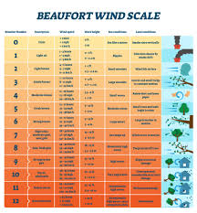
Weather conditions
See Weather Risk assessment below

“There is no such thing as bad weather, only inappropriate clothing”
All children will need to be dressed appropriately for the weather conditions, however there are some circumstances where it may not be practical or safe to go ahead with the planned session due to extreme weather this would be considered at number 6 on the Beaufort Wind Scale. At this point, the session will either take place in the forest school classroom or on the open school field. The main concern with weather is high winds, as this can cause movement within trees. Changes to session will be at the discretion of the Forest School lead and senior management team.
Activities we might do within Forest School
Activities we might do as part of a Forest School session are diverse and numerous, we are trying to create independent learners who are inspired to try out their own ideas, explore their own interests and to attempt new ideas.
Some activities might include:
- Shelter building
- Fire lighting and cooking on an open fire See Food and Campfire Cooking Risk assessment below
At Forest School children will have the opportunity to prepare and make basic snacks. All food that is prepared is prepared during the session as close to cooking time as possible.
- Using a Kelly kettle
- Digging for treasure (bugs, stones, tree roots)
- Mud potions
- Tool use
- Puddle jumping
- Studying wildlife
- Playing team and group games
- Sensory activities
- Rope and string work (tying knots)
- Art and sculpture work using natural resources.
- Woodland and traditional craft
- Woodland management
- Tree climbing
- Camera use to help explore the beauty of the world.

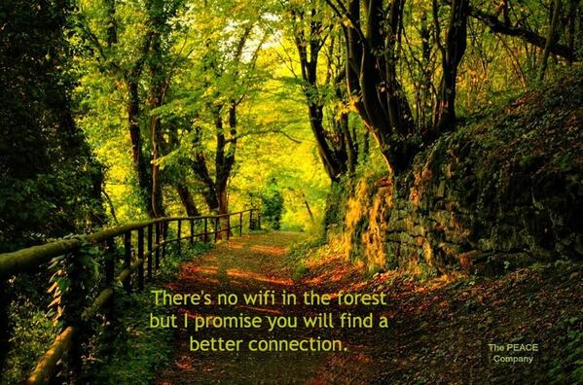

Forest School is lots of fun
Playing in the rain or sun,
Building dens and climbing trees
Seeing flowers that make you sneeze,
Watching bugs creep and crawl,
Are they big or are they small?
Forest School is lots of fun playing in the rain or sun.

Equipment and clothing
Supporting yourself or your child in Forest School.
As the song above suggests we explore the natural world in all seasons and it is therefore important that your child is dressed with the right clothes to ensure comfort and safety in all weathers.
Over the next few pages, we explain how to dress yourself or your child depending on the season and weather.
Please always remember your child will be outside for up to two hours. Your child is a lot smaller than you, so it is harder for them to regulate their body temperature. If you are not appropriately dressed you can lose body heat up to 25% faster.
“There’s no such thing as bad weather, just bad clothing…
the art is layering!”
Kit list
No matter the season, please provide clothing which you don’t mind getting muddy. In all season’s learners will need to bring spare clothes (they may get wet and muddy and need to change before going back to class/home. No matter the season learners will need to wear long trousers (no shorts) and long-sleeved tops (no t-shirts) within the woodland, as there are many plants and insect that might sting, scratch or bite. To reduce the chance of this occurring, it is required to cover arms and legs.
Top tips
Once children get cold, they find it hard to warm up, so getting the layers right before heading out is key.

Check your child is comfortable and can move with ease.
Natural materials like wool are best for warmth and comfort.
Wearing lots of thin layers is better than wearing fewer thick layers.

What to wear in summer
- Summer waterproofs
- One pair of comfortable trousers
- One light long sleeved top
- One pair of socks
- Wellies or sturdy closed-toe shoes
- A sun hat and sun cream for sunny days

What to wear in Spring/Autumn
- Waterproof trousers and coat
- One pair of comfortable trousers
- One long sleeved top
- A t-shirt over the long sleeves top
- One thick jumper/One fleecy zip up jacket
- Two pairs of socks. Thin wool or wool blend sock,and a thick wool or fluffy thermal sock
- Wellies or sturdy closed-toe shoes

What to wear in Winter
- Winter waterproofs (thermal lining clipped in)
Legs
- Base layer (tights or under armour)
- Leggings
- Thick tracksuits
Body
- Vest
- long sleeve thermal layer
- T-shirt
- Thin fleece top
- Jumper/Sweatshirt
- Waterproof coat (no duvet/padded coat, no fur and not full length- the woodland is muddy and wet, these coats soak up the mud and water)
- Neck snood (no scarfs)
- Hat and gloves
- Three pairs of socks (one pair could include tights, Spare socks for after the session)
- Snow boots/ Wellies or sturdy warm outdoor boots (spare dry shoes)
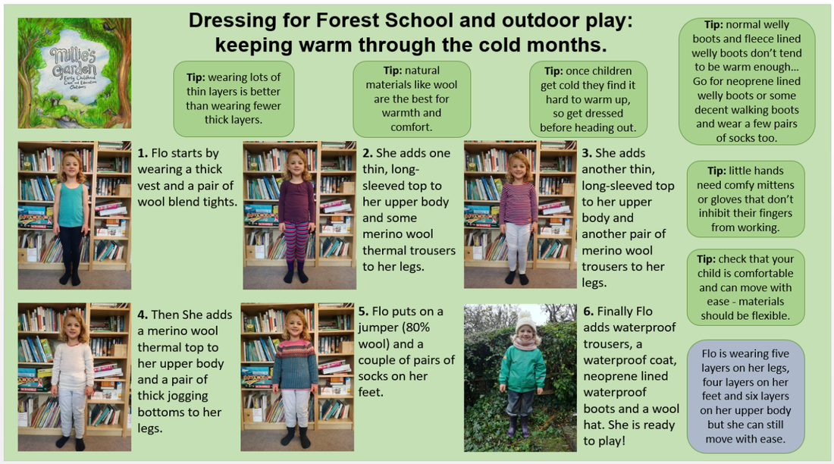

Ticks
Due to the nature of forest school, there is a small risk of ticks. We have a number of provisions in place to limit this. This includes:
- Children wearing appropriate clothing, long sleeves and trousers
- Grass cut regularly
- Informing the children about the risks of ticks and what to do if they discover a tick on themselves.
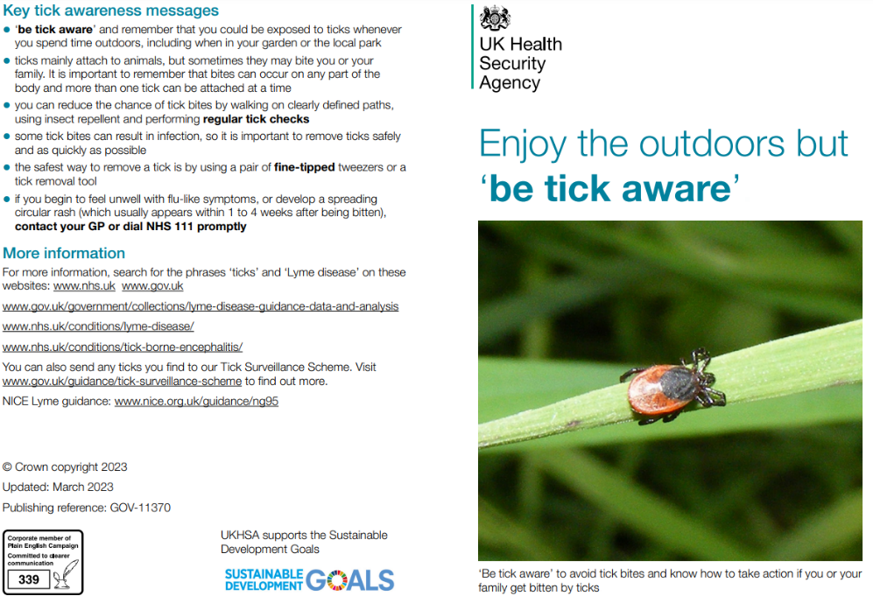
If a child does find a tick we have a tick remover tool on site.
Parents are advised to check their children after forest school and informed us if a tick has been discovered.



